**Docker & Docker Hub**

**Assignment 1:**

Demonstrate minimum 15 basic docker command with explanation and screenshot.

1. Command: docker run nginx

The docker run command **creates running containers from images and can run commands inside them**. When using the docker run command, a container can run a default action

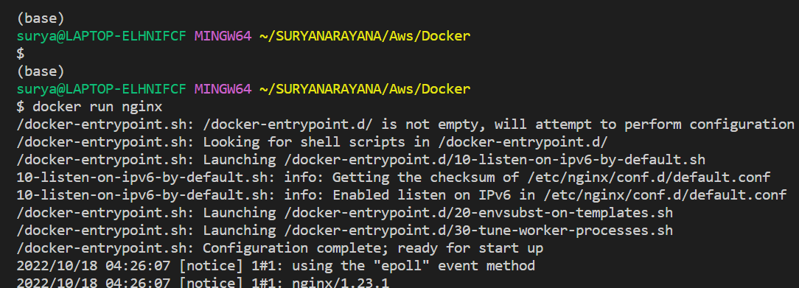

1. Command: docker ps

Docker has used the naming convention of ps from Linux; ps means 'process status' in Linux, and containers are actually running as a process on the Linux server; that's why 'docker ps' is **used to list the containers** which are live running containers.

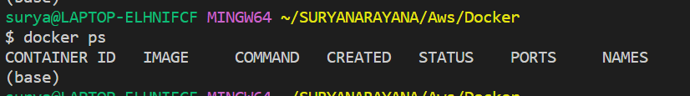

1. Command: docker ps -a

The docker ps command only shows **running containers by default**. To see all containers, use the -a (or --all ) flag

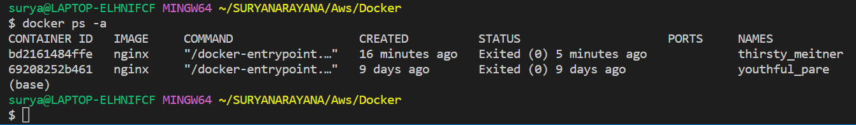

1. Command: docker stop [OPTIONS] CONTAINER [CONTAINER...]

To stop one or more running Docker containers, you can use the **docker stop command**.

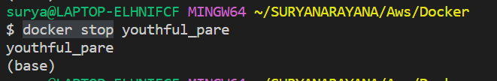

1. Command : **docker rm <container id>**

Procedure to remove data collector Docker container · Run the following command to remove Docker container: docker stop <Container_ID> **docker rm** <Container_ID>

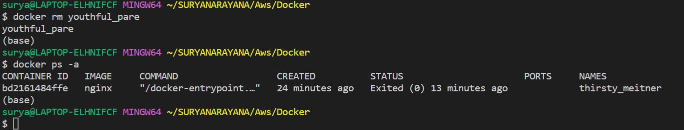

1. Command : docker images

A Docker image is **a file used to execute code in a Docker container**. Docker images act as a set of instructions to build a Docker container, like a template. Docker images also act as the starting point when using Docker. An image is comparable to a snapshot in virtual machine (VM) environments. To list all running docker images we use docker images.

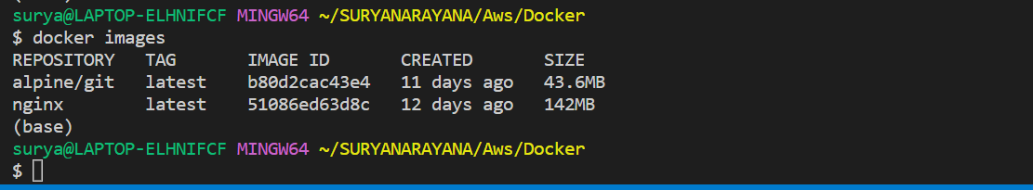

1. Command: **docker rmi <image-id>**

Removes (and un-tags) one or more images from the host node. If an image has multiple tags, using this command with the tag as a parameter only.

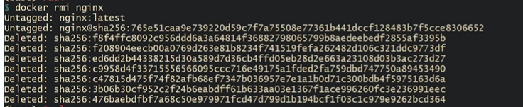

1. Command: docker pull nginx

**Docker enables you to pull an image by its digest**. When pulling an image by digest, you specify exactly which version of an image to pull. Doing so, allows you to “pin” an image to that version, and guarantee that the image you're using is always the same

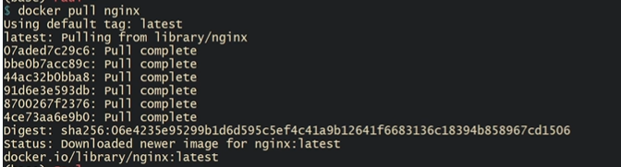

1. Command : docker run ubuntu sleep 5

T the usual reason to use sleep as a command **to run a docker container is** docker container will live until the command it runs finishes. This command is normally set in the Dockerfile used to build the image (in a CMD stanza) and can be overridden on the command line

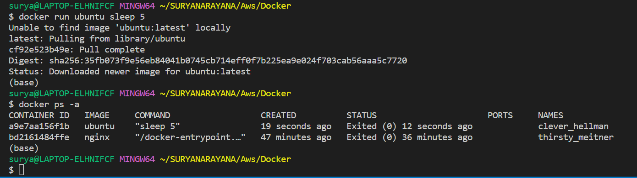

1. Command: docker run -it ubuntu bash

This command is used to access the running container.Running commands inside a container. The --**interactive option runs** an **interactive container**, and the --**tty** flag attaches a dummy **terminal**. Now I am inside my container.

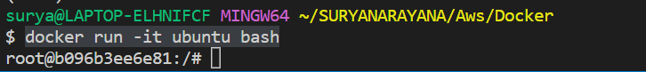

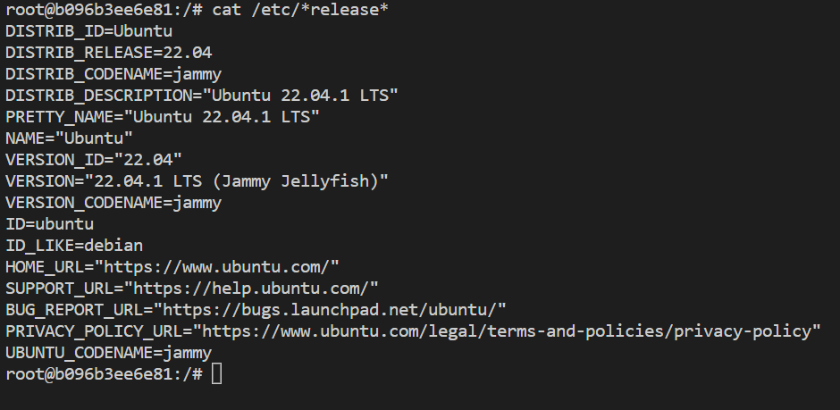

1. **Command: docker – help**

It gives options of help for docker commands.

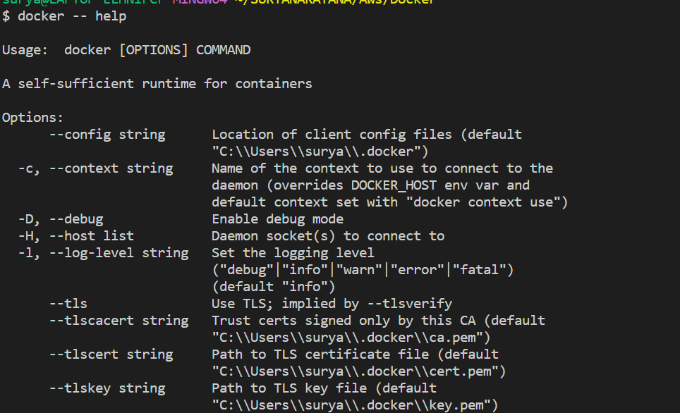

1. Command: **docker build -t <image name> .**

This command is used to build an docker image from current directory.

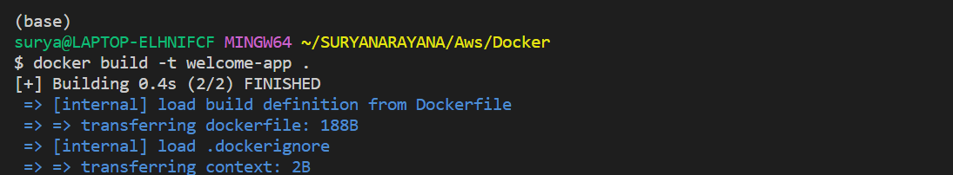

1. Command : **docker kill <container id>**

This command kills the container by stopping its execution immediately. The difference between ‘docker kill’ and ‘docker stop’ is that ‘docker stop’ gives the container time to shutdown gracefully, in situations when it is taking too much time for getting the container to stop, one can opt to kill it.



1. Command: **docker –version**

This command is used to get the currently installed version of docker

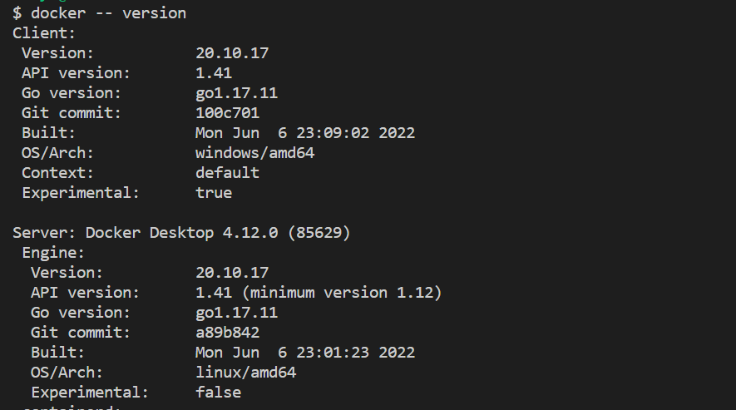

Command : **docker commit <conatainer id> <username/imagename>**

This command creates a new image of an edited container on the local system

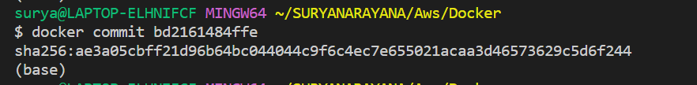

**Assignment 2:**

[Hello World Docker Image](https://hub.docker.com/_/hello-world) Run Hello World Docker Image Locally.

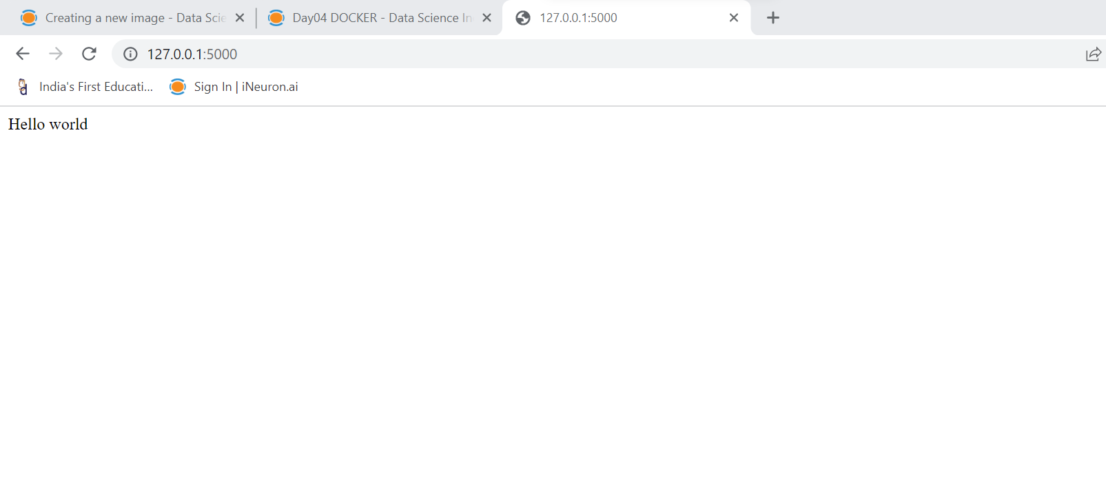

**Assignment 3:**

Create a hello world fastapi application. Create a Dockerfile for your fastapi hello world application. Build Docker image using Docker file. Run docker image build in previous step. Push your Docker image to Docker Hub.

